1. Estimate the part-worth and attribute importance

We estimated the average part-worth and attribute importance on basis of 50 responses collected at random (Excel file attached)

1. attribute importance
2. 1 Brand 24.10
3. 2 Capacity 16.21
4. 3 Time.to.form.ice 8.40
5. 4 Door 18.77
6. 5 Price 32.52

b) Suggest a product for Samsung. Justify your recommendation.

Samsung has existing market share of 23% and 24.5% respectively for the following existing products:

|  |  |  |  |  |
| --- | --- | --- | --- | --- |
| Samsung | 330 | 45 | Double | 21000 |
| Samsung | 270 | 45 | Double | 18000 |

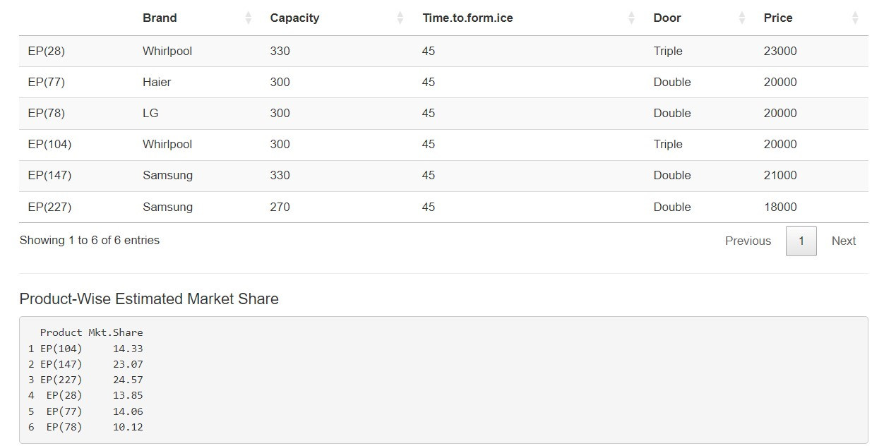

Total market share of Samsung for existing products is 47.5%

We recommend Samsung_330_15_Double_18000 as the new product, it gets a market share of 20.03% and the existing products of Samsung saw minimal change in market share.

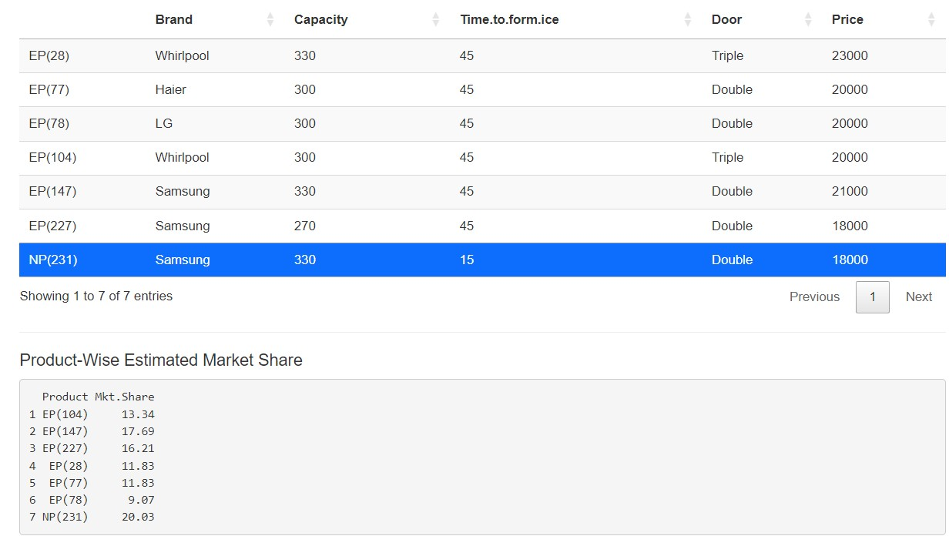

Upon introducing the new product, the marked share of Samsung increase to 54.1%

c) Give your recommendation to Samsung management.

We recommend placing the above new product in segment 2 as it elevates the market share further keeping the key attributes (Price, Time to form ice) in focus.

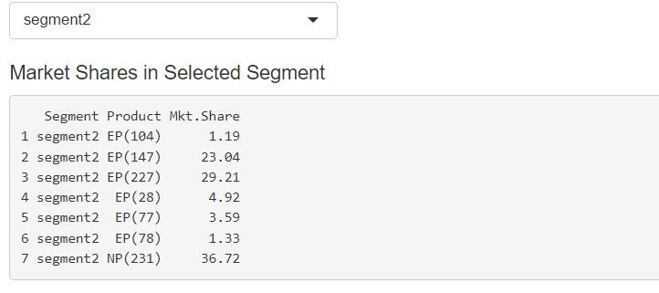

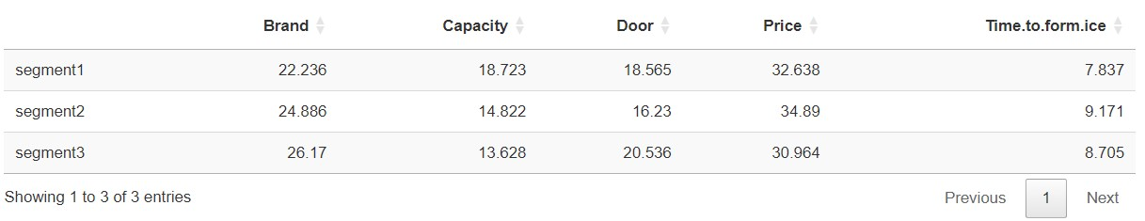

**Group 3**

Shashank Agrahari

Geetika Sikka

Jaya Prakash Narayan

Rajesh Selvam

Gamya